# CS 255 System Design Document Template

Nathaniel Frazier

CS255

## UML Diagrams

### UML Use Case Diagram

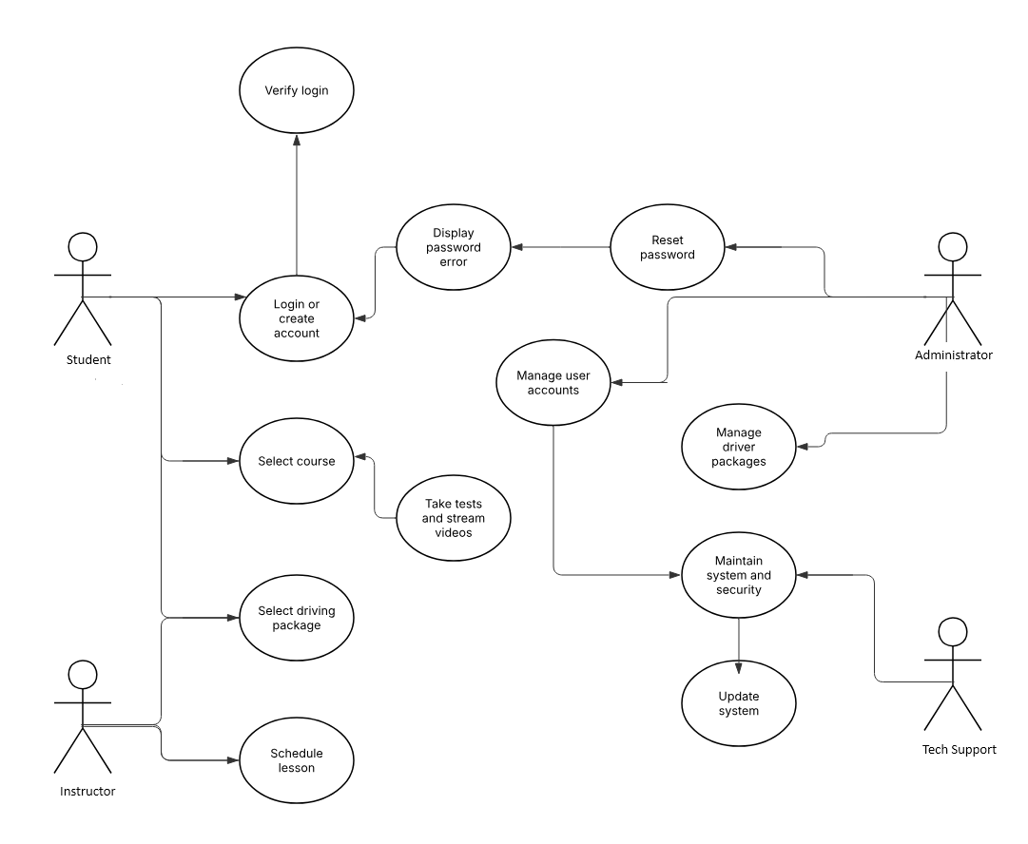

### UML Activity Diagrams

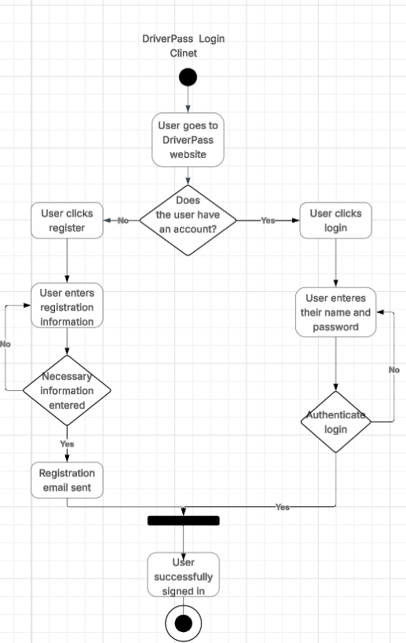

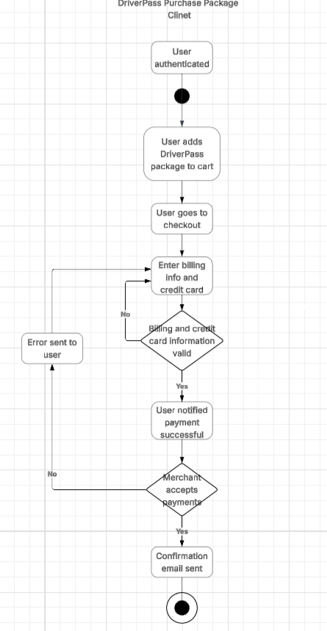

### UML Sequence Diagram

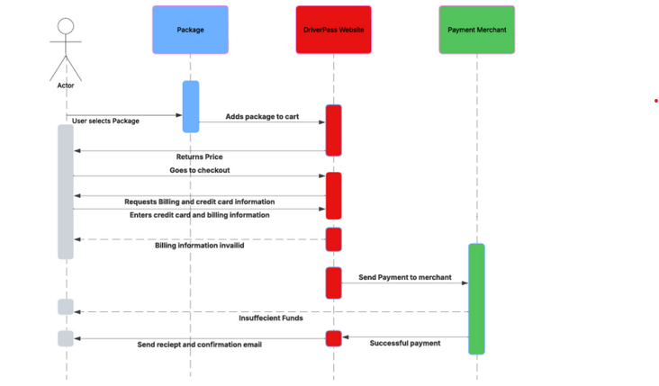

### UML Class Diagram

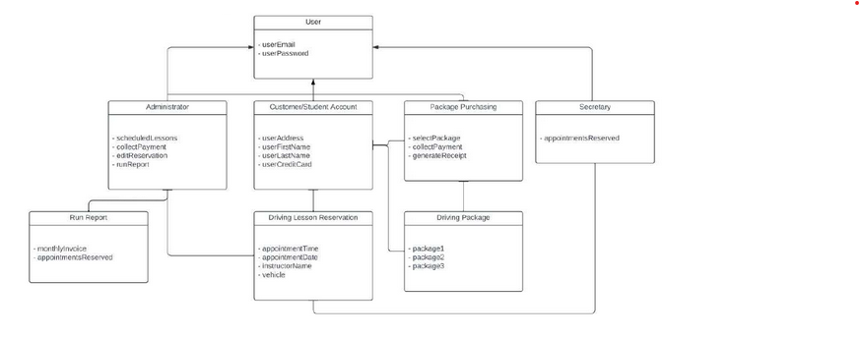

## Technical Requirements

Hardware

* A firewall to secure website ports
* A dedicated server
* Storage for database and website data
* Internet connection
* Computer or mobile device for user access to the website

Software Requirements:

* Utilization of Windows Server (recommended) for its stability.
* Deployment of SQL Server (recommended) for the database (most stable release)
* Integration of backup software for both website and database
* Implementation of a web server such as Apache
* Inclusion of security software to prevent malware threats

Geographical Considerations

* Securing website and database in a data center.
* Make sure the server is in a central location in order to better performance.
* Ensure that the website is capable of being accessed in it home country of
* America.